**Light Intensity**

* Falls off with distance by a constant rate
  + The initial distance divided by the final distance all squared

**Power**

* Intensity: power transferred per unit area
* Solar Constant: Amount of solar radiation the Earth receives per unit area

**Electromagnetic Radiation**

* All object release some form of E.M waves
  + Depends on temperature (Thermal radiation)
    - The colors they produce are dependent on how much E.M radiation the atoms inside the object are producing. The frequency at which that radiation is at will allow us to determine its color. If a piece of metal is sitting in the fire and glows red hot, that means that the frequency of the E.M radiation emitted from the metal is in the range of visible light red [to us humans].

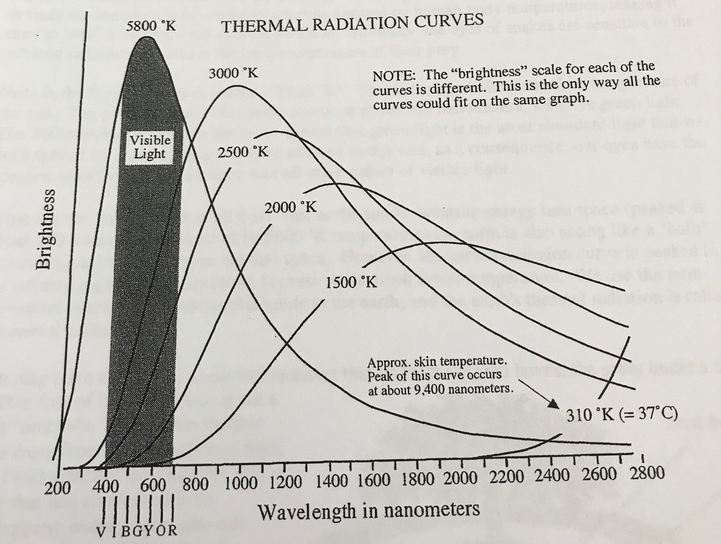

**Stefan-Boltzmann Law**

* Total radiation radiated by a blackbody, all wavelengths taken into account
* The hotter an object is the amount of energy radiated will be the fourth power of the temperature ratio.